Forecasting & Cancellation Trends
Module 4

1. Overview
The Forecasting & Cancellation Trends module is designed to provide actionable insights into future occupancy, booking behaviours, and revenue risks. By analysing historical data, lead times, and cancellation patterns, this module enables the hotel management team to optimize pricing strategies, manage resources efficiently, and mitigate revenue leakage.
2. Business Objectives
- Informed Decision-Making: Move from guesswork to data-driven strategies for pricing and inventory.
- Risk Management: Identify potential revenue losses through Cancellation and No-Show tracking.
- Operational Efficiency: Align staffing and inventory with predicted occupancy levels.
- Cash Flow Management: Anticipate refunds and revenue adjustments to maintain healthy financials.

3. Data Preparation & Modelling
To support the analysis, the following Calculated Columns must be added to the Bookings table in Power BI.

Required Columns
- Booking Date: Date the reservation was made.
- Lead Time: The number of days between the Booking Date and the Check-in Date.
- NoShow Flag: Binary indicator for no-shows.
- Cancellation Flag: Text indicator for cancellations.
- Refund Amount: The monetary value associated with a cancellation.
- Refund Flag: Binary indicator if a refund exists.

Formulas:
- CancellationFlag = IF(Bookings[BookingStatus] = "Cancelled", "Yes", "No")
- NoShowFlag = IF(Bookings[BookingStatus] = "No-Show", 1, 0)
- RefundAmount = IF(Bookings[BookingStatus] = "Cancelled", Bookings[Revenue], 0)
- RefundFlag = IF(NOT(ISBLANK(Bookings[RefundAmount])), 1, 0)
- BookingDate =
VAR CheckInDate = Bookings[CheckInDate]
VAR PriorMonthDate = EOMONTH(CheckInDate, -1) + 1
VAR DaysBetween = DATEDIFF(PriorMonthDate, CheckInDate, DAY)
VAR RandomOffset = RANDBETWEEN(0, DaysBetween)
RETURN PriorMonthDate + RandomOffset
- LeadTime = Bookings[CheckInDate] - Bookings[BookingDate]

4. DAX Measures:

4.1 Bookings: counts the total number of booking records.
- Bookings = COUNTROWS(Bookings)

4.2 Cancellation Rate: The percentage of total bookings that resulted in a cancellation.

- CancellationRate =
DIVIDE(
COUNTROWS(FILTER(Bookings, Bookings[CancellationFlag] "Yes")),
COUNTROWS(Bookings)
)

4.3 NoShow Count: Total number of bookings where the guest did not arrive.

- NoShowCount =
CALCULATE(
COUNTROWS(Bookings),
Bookings[BookingStatus] = "No Show"
)

4.4 Refund Count: Total number of bookings where a refund was processed.

- RefundCount =
CALCULATE(
COUNTROWS(Bookings),
Bookings[RefundAmount] > 0
)

5. Dashboard Visualizations:

5.1 Future Occupancy
- Visual Type: Line Chart with Forecast
- X-Axis: Date (Month/Year)
- Y-Axis: Average of Occupancy %
- Toggle Forecast On in Analysis tab
- Feature: Uses Power BI's built-in "Forecast" analytics feature to project future trends based on historical patterns (Seasonality)
- Purpose: Allows the team to predict demand and adjust resources
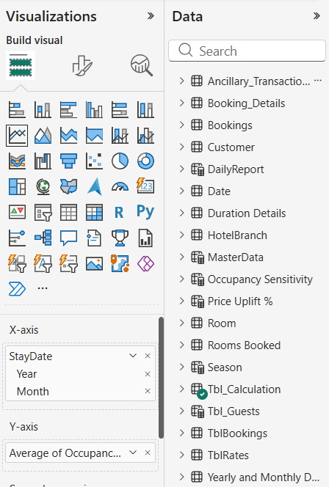
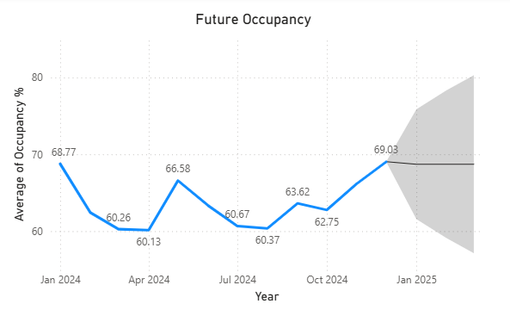

5.2 Cancellation Rate
- Visual Type: Line Chart
- X-Axis: Date
- Y-Axis: CancellationRate measure.
- Purpose: Monitors spikes in cancellations. High cancellation rates may trigger a review of booking policies or deposit requirements.
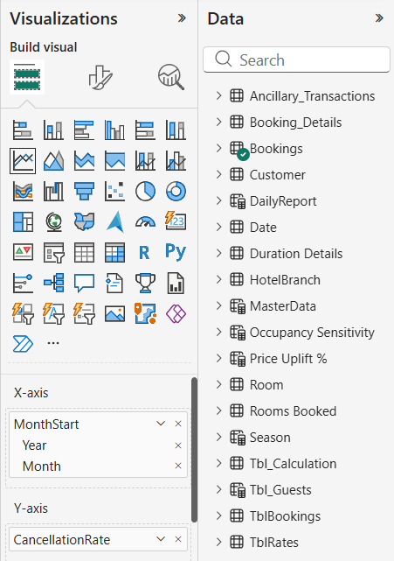
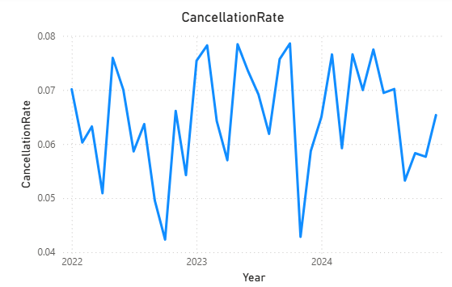

5.3 Lead Time Distribution
- Visual Type: Bar Chart
- Y-Axis: Lead Time (Bins or specific days).
- X-Axis: Count of BookingID.
- Purpose: Analyzes how far in advance guests book.
  - Short Lead Time: Corporate/Business travelers.
  - Long Lead Time: Leisure/Group travelers.
  - Insight: Helps in defining "Early Bird" offers vs. "Last Minute" pricing
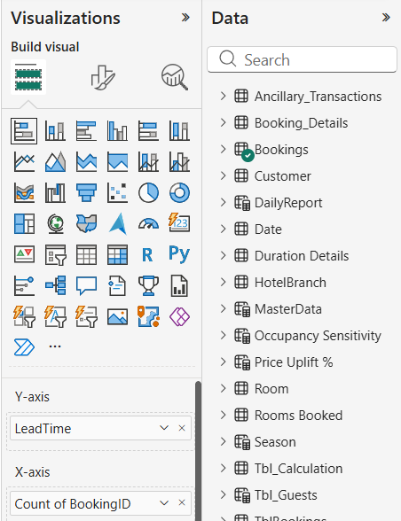
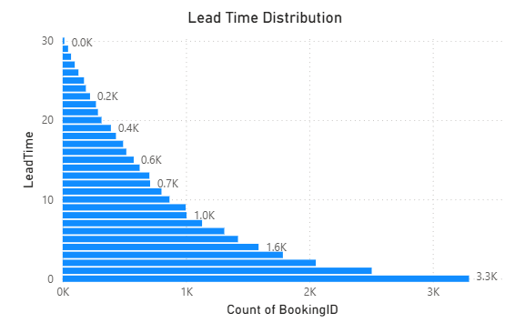

5.4 RefundCount and NoShowCount by Year

- Visual Type: Stacked Column Chart
- X-Axis: Year
- Y-Axis: Count of Refunds / No-Shows.
- Legend: RefundCount, NoShowCount.
- Purpose: Tracks operational waste and revenue leakage over time
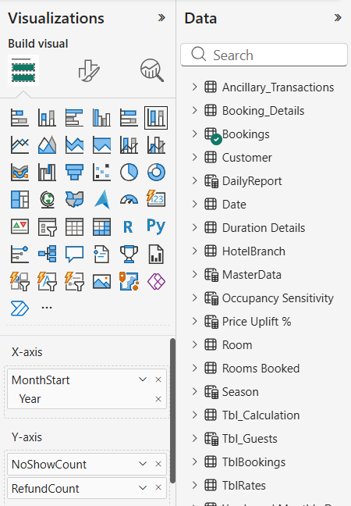
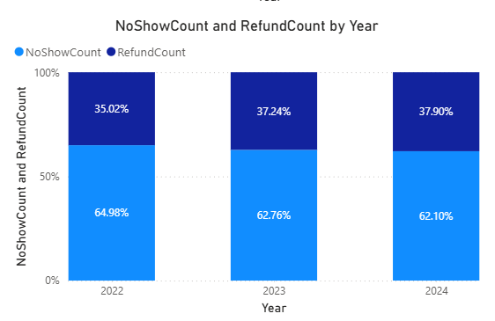

6. Insights
- Pattern Recognition: Use the historical data to set a baseline. If the "Future Occupancy" forecast dips, marketing efforts should be increased for those specific dates.

- Dynamic Pricing: Use the Recommended Price measure along with the Lead Time chart. If lead times are shortening, prices can be adjusted to capture late-booking corporate demand at a higher rate.

- Policy Management: If CancellationRate and RefundCount are high for bookings with long lead times, consider implementing stricter cancellation policies for advance bookings

